**MOSFETS**

A metal–oxide–semiconductor field-effect transistor (MOSFET, MOS-FET, or MOS FET) is a field-effect transistor (FET with an insulated gate) where the voltage determines the conductivity of the device. It is used for switching or amplifying signals. The ability to change conductivity with the amount of applied voltage can be used for amplifying or switching electronic signals. MOSFETs are now even more common than BJTs (bipolar junction transistors) in digital and analog circuits.

The silicon dioxide forms the gate of the mosfets. It is used to provide isolation by prevent the direct flow of charges on gate to the conducting channel.

Conducting plate

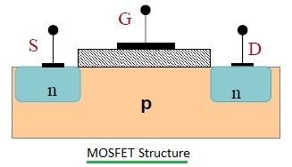

Source

Drain

Isolation

Gate

**It is NPN Type of MOSFET**

N side contains electrons and P side is contains holes.

A MOSFET is by far the most common transistor in digital circuits, as hundreds of thousands or millions of them may be included in a memory chip or microprocessor. Since they can be made with either p-type or n-type semiconductors, complementary pairs of MOS transistors can be used to make switching circuits with very low power consumption, in the form of CMOS logic.

**Why use of MOSFET?**

MOSFET are usually used in amplifiers due to having infinite input impedance it accepts all the incoming signals. And doesn’t consume any amount to current to control the load current when compared to BJT.

Type of MOSFETS: -

**Depletion type:** The transistor requires the Gate-Source voltage (VGS) to switch the device “OFF”. The depletion-mode MOSFET is equivalent to a “Normally Closed” switch.

**Enhancement Type:** The transistor requires a Gate-Source voltage (VGS) to switch the device “ON”. The enhancement-mode MOSFET is equivalent to a “Normally Open” switch.

**MOSFET Device Structure**

It is a four-terminal device with source (S), drain (D) and gate Terminal (G) and body (B) terminals. The body is frequently connected to the source terminal, reducing the terminals to three. It works by varying the width of a channel along which charge carriers flow (electrons or holes).

The charge carriers enter the channel at source and exit via the drain. The width of the channel is controlled by the voltage on an electrode is called gate which is located between source and drain. It is insulated from the channel near an extremely thin layer of metal oxide. A metal-insulator-semiconductor field-effect transistor or MISFET is a term almost synonymous with MOSFET. Another synonym is IGFET for the insulated-gate field-effect transistor.

**MOSFET Operation**

The working of a MOSFET depends upon the MOS capacitor. The MOS capacitor is the main part of MOSFET. The semiconductor surface at the below oxide layer is located between the source and drain terminals. It can be inverted from p-type to n-type by applying positive or negative gate voltages.

When we apply positive gate voltage the holes present under the oxide layer with a repulsive force and holes are pushed downward with the substrate. The depletion region is populated by the bound negative charges which are associated with the acceptor atoms. The electrons reach the channel is formed. The positive voltage also attracts electrons from the n+ source and drain regions into the channel. Now, if a voltage is applied between the drain and source, the current flows freely between the source and drain and the gate voltage controls the electrons in the channel. If we apply negative voltage, a hole channel will be formed under the oxide layer.

### P-Channel MOSFET

### 

Substrate

* The drain and source are heavily doped p+ region and the substrate are in n-type.
* The current flows due to the flow of positively charged holes also known as p-channel MOSFET.
* When we apply negative gate voltage, the electrons present beneath the oxide layer experience repulsive force and they are pushed downward into the substrate, the depletion region is populated by the bound positive charges which are associated with the donor atoms.
* The negative gate voltage also attracts holes from the P+ source and drain region into channel region.

**N-Channel MOSFET**

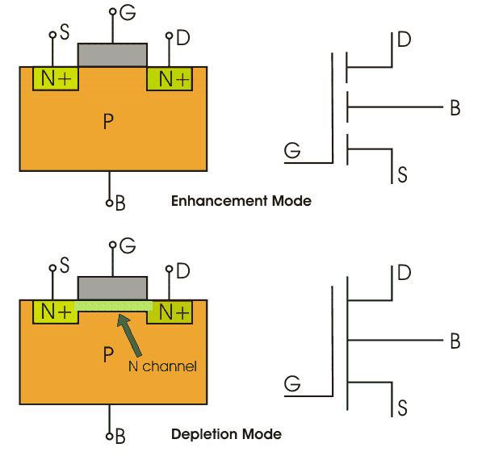

Substrate

* The drain and source are heavily doped N+ region and the substrate are p-type.
* The current flows due to the flow of negatively charged electrons, also known as n-channel MOSFET.
* When we apply the positive gate voltage the holes present beneath the oxide layer experience repulsive force and the holes are pushed downwards into the bound negative charges which are associated with the acceptor atoms.
* The positive gate voltage also attracts electrons from the N+ source and drain region into the channel thus an electron reach channel is formed.